First Grade Newsletter


Mrs. Otterman’s Class Room 8
Week of March 9 – March 13, 2020

Math

Monday ~ Students make picture graphs (HW) Lesson 3

Tuesday – Students read picture graphs
(H.W.) Lesson 4
**Timed Math Tests

Wednesday – Students complete “Check My Progress” page

Thursday – Students make bar graphs (HW) Lesson 5
**Timed Math Tests

Friday – Students read bar graphs

**Please continue to have your child practice facts using the number line & math facts at home. This will help build mental math facts and fluency when completing independent work. They can show me at school what they know as well! ☺
Language Arts –
We will discuss the story “Tomas Rivera” this week…We will be discussing long o (oa; ow) verbs & time; Sequence Order, contractions ‘ve; ‘re as well as continue sentence “rules.”

Monday~Send “cold read” fluency and comprehension practice for home use

Wednesday~ Spelling Test; ½ Weekly Test

Thursday~ Finish Weekly Test; Oral Vocabulary Quiz…Comprehension Quiz “Our Goat”

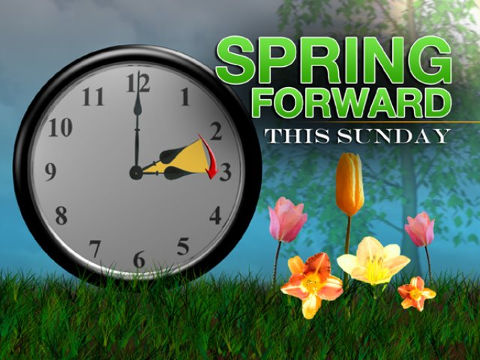

Don’t forget to change your clocks ahead one hour on Sunday, March 8….

**Please return pencil stamped homework so the students can get their stickers for their homework charts. Please make sure homework is signed as well. Thank you ☺

Schedule

Monday – Day 3~ Music
Tuesday – Day 4~ Library
Wednesday – Day 5~ Library; Gym (please wear appropriate clothing)
Thursday – Day 6~ Art
Friday - Day 1~ Music

(Mrs. Otterman’s classroom library will be every Day 2)

Upcoming Events

Monday~ Occupation Visit~ Mrs. Kirsch 2:45

Friday~ Show and Tell
“A St. Patrick’s Day Item”

Donations:
If anyone wants to donate something to our classroom, then we are in need of pretzels and/or graham crackers…Thank you!! ☺

Please send Field Trip permission slips and any interested chaperoning slips back by next Friday, March 13…Thank you! ☺

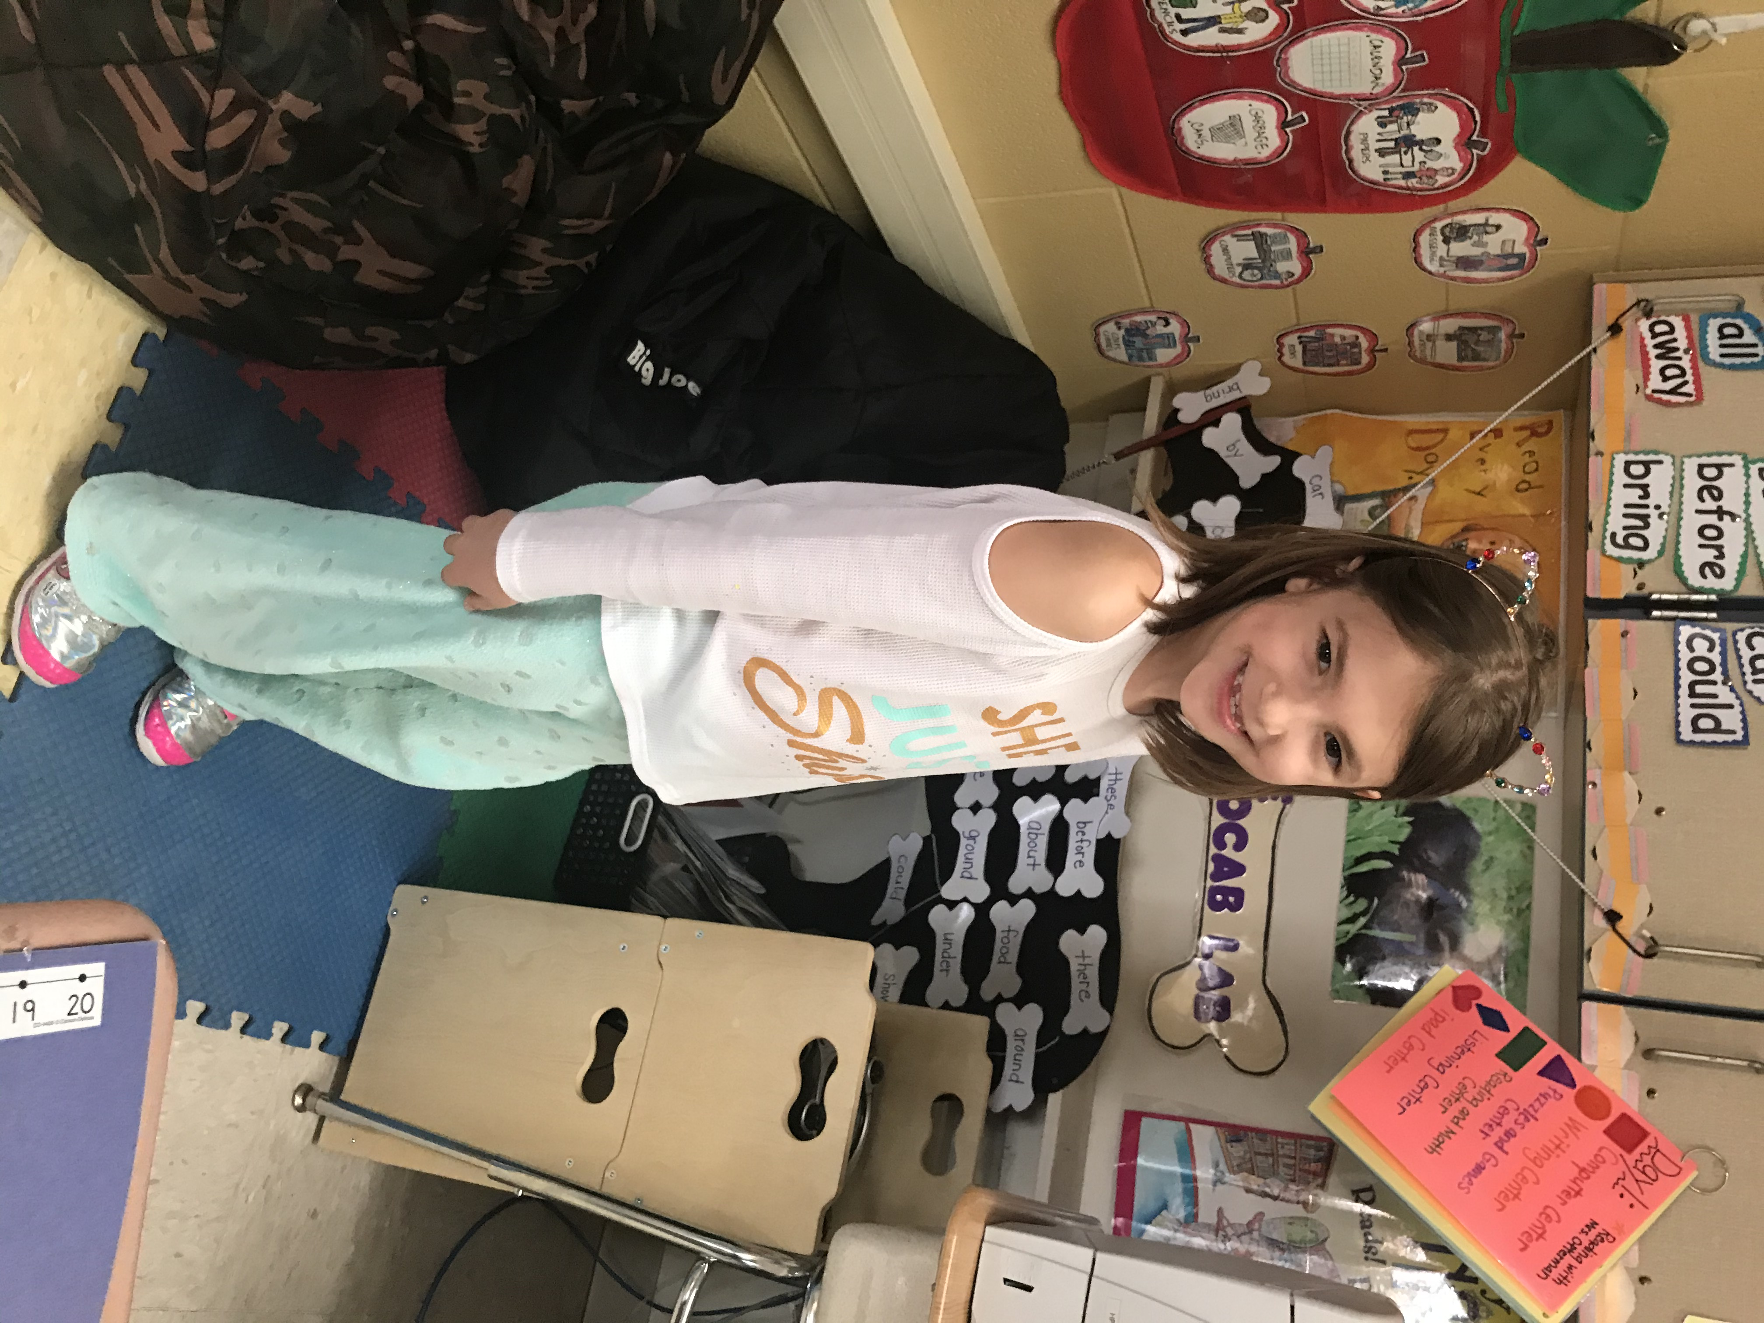

Ivan… March 8


Vocabulary Words (Oral Vocabulary Quiz…March 12) “Tomas Rivera?”:

done

soon

great

talk

laugh

were

paper

work

Important News:
Please note the following: I hang the Math tests that are correct and the spelling tests on the Star Board in our room if they get all the words correct. This earns them a “sponge fry” for our bulletin board. Please know the Weekly Tests will be read by me for the first and part of the second half of first grade, but students will be required to read the given answers independently (for most of the questions).

Spelling Words…Lesson 19…Test on March 11)

show

row

boat

blow

toad

road

low

coat

grow

snow

flown

toast

*These tests will always be on Day 5 (unless otherwise noted)

Bundle Up!!!
The winter weather is here! Please make sure your child has a MARKED winter coat, gloves, and a hat when the weather is brisk. I told them to keep a pair of gloves and a hat in their book bag (if needed) since we never know what the weather could be like at this time of the year. Please also know that first grade will keep anyone in at recess who is not dressed appropriately. Thank you for your help! ☺

Student of the Week
Clare Woida

